**CRUD OPERATIONS:**

1. **Insert /View –Refer Console snapshot and output window**.

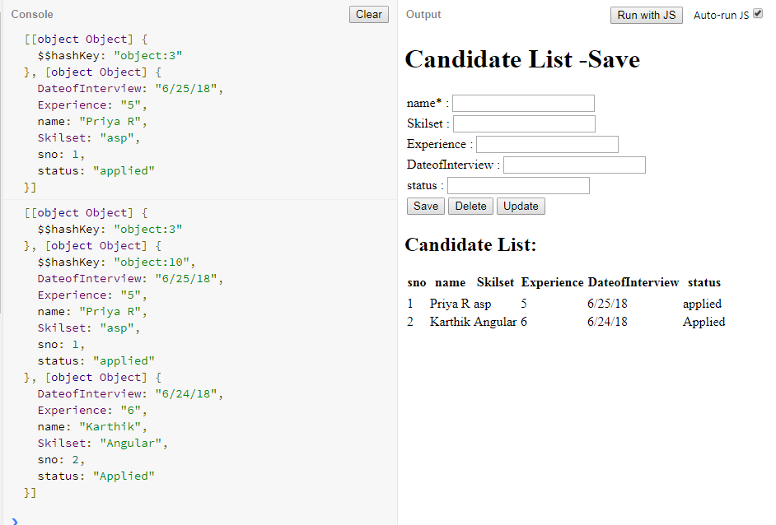

**2) Update - The First record “Priya R ” name with an array value is updated . Kindly check this value with previous screen shot**. 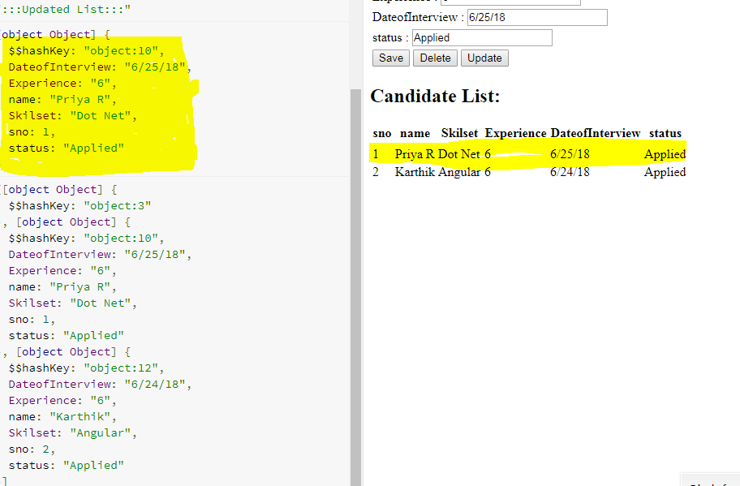

3) Delete –I am deleted the second row. Kindly check the below snapshot. 